BEST PRACTICES FOR BACKING FIRE APPARATUS AND AMBULANCES

PURPOSE

The purpose of this guideline is to outline proper safety practices to be used when backing Fire Department vehicles and maneuvering in close-quarters situations.

Fire department vehicles will be backed and maneuvered without hitting a person, object, or other vehicle.

Using the information provided in this Best Practice Guide virtually eliminates the possibility of hitting a person, object, or other vehicle while backing or maneuvering in close-quarters. Therefore, all Department personnel will be expected to follow the guidelines contained in Sections III and IV of this procedure and, in addition, take all reasonable and necessary actions to comply with these Best Practices. Hitting a person, object or other vehicle while backing a fire department vehicle is an unacceptable event.

These Best Practices will apply when backing a department vehicle, when maneuvering Fire Department apparatus and ambulances with restricted rear visibility, or in situations where vehicle clearances are uncertain.

Accountability

The company officer or acting officer will be responsible for all vehicles assigned to his/her company and the overall compliance of his/her company personnel with the guidelines provided in these Best Practices at all times. Each vehicle driver will be responsible for the safe operation of his or her vehicle at all times. This includes ensuring the vehicle is safely backed and maneuvered without incident.
Procedure

The following Best Practices will be used to ensure that Department vehicles are backed and maneuvered safely and without incident:

A. The need to back a department vehicle will be avoided when at all possible by positioning the vehicle so to have a forward egress route. Attempt to avoid situations that require vehicle backing or close-quarter maneuvering such as dead ends, cul-de-sacs, and routine parking situations whenever possible. Simply put better to drive one mile straight then to back up a mere fifty feet.

B. When backing is unavoidable, a minimum of one ground guide person will be assigned and used. It is the responsibility of the officer, if present, or the driver operator if no officer is present to assure that a ground guide is assigned when necessary. In addition, ground guide(s) will be used when a vehicle must negotiate forward turns with restrictive side or rear clearances and where clearances above or beneath the vehicle are uncertain. This is especially critical with large tender / tankers apparatus in a rural setting and aerial apparatus in a crowded urban setting.

C. The vehicle driver operator will determine the necessary number of ground guide personnel, with a minimum of one (1), to ensure the vehicle is backed and maneuvered safely without striking a person, object, or other vehicle.

D. It is the driver’s responsibility to verbally communicate their planned vehicle backing route and procedures with the ground guide(s) prior to backing.

E. It is advisable that the ground guide has a portable radio with them when spotting a vehicle. When the driver and backer agree to use a radio channel as the primary means of communicating during backing or maneuvering, it is the ground guide’s responsibility to initiate communication with the driver by radio and receive an acknowledgment from the driver to insure that this radio communication is established. The vehicle shall not be backed until this two-way radio communication has been verified.

F. When a ground guide is assigned, the apparatus will never be put in reverse gear until the ground guide(s) is in position and has signaled visually or by radio, their approval to start backing.

G. Due to the potential to back over the ground guide and for the existence of a significant blind spot on the passenger’s side of a backing vehicle, consideration should be given to positioning a ground guide on the left side of the backing vehicle, within view of the driver instead of looking in their right-side mirror. Under these situations, the driver can roll down the window looking out the driver’s side and use their right mirror to view the officers side of their vehicle while constantly monitoring the ground guide.

H. The vehicle will be immediately stopped any time one of the following situations exists:

1. The driver loses sight of or breaks visual contact with the ground guide.

- The driver is confused or unsure of the signals being provided by the ground guide.

- The driver receives a visual, verbal, or radio communication to STOP.

The driver may continue backing the vehicle only after the above situations are corrected and the communication to continue backing is given by the ground guide(s).

I. A highway safety vest or turnout coat shall be worn by all ground guides during the backing process. When backing a vehicle in or near moving traffic, the vehicle's emergency lights can be operated at the discretion of the driver or officer unless their operation will in any way hinder the vision of the ground guide. Understanding that today’s emergency vehicle lighting could actually blind civilian drivers, other fire apparatus driver operators or the ground guide.

J. When backing vehicles at night, ground guides should consider turning on and properly aiming the vehicle's rear spotlights or scene lights (if equipped with such lights) to better illuminate the backing area. Fire departments specifying new apparatus may consider having this additional lighting hard wired to the automatic transmission to activate when the vehicle is put in to reverse gear. In addition, ground guides may use flashlights to assist the driver, but at no time shall the flashlight beam be directed toward the vehicle mirrors or in the eyes of civilian drivers.

K. Ground guides are never permitted to ride on the backing vehicle while in motion.

L. In circumstances where the vehicle is occupied by only the driver and backing without a guide is unavoidable, the driver will accomplish three basic tasks; 1) Shall exit the vehicle to assure that a complete 360-degree survey of the area around the vehicle has been conducted to determine what, if any, obstructions are present. 2) attempt to use any available Department personnel, police officer, City employee, or other individuals to serve as improvised ground guides, 3) where no personnel are available to assist, the vehicle may be cautiously backed but only after conducting a 360 while watching for pedestrians, vehicles, and obstructions that may enter the path of the moving vehicle. It is the driver’s responsibility to assure that their audible back-up alarm is sounding before moving the vehicle.

M. Today many new technologies exist to aid in the safe backing of apparatus ie. Cameras, Back Stops, and head set radios however these technologies do not negate the use of a ground guides. Driver operators need to constantly, visually monitor the ground guides and not be watching the camera T.V. in the cab.

N. Backing of a vehicle while responding to or operating at emergency incidents necessitates consideration for safety at all times and a common sense approach to vehicle backing. Every reasonable and prudent effort shall be made to comply with these backing or close quarter maneuvering safety guidelines during emergency response or incident scene conditions.

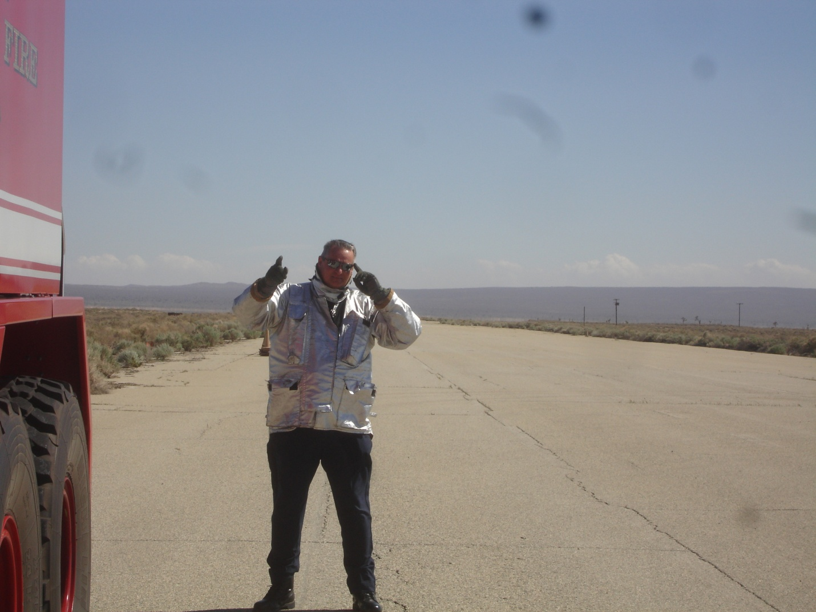
ATTENTION: To start make sure that the driver and the backer are in sync with one another and that both are paying attention. The backer faces the vehicle takes left hand pointing towards the eyes while motioning with the right hand.
This alerts the driver that the backer is in place and ready to proceed and prevents the driver from backing over the backer.

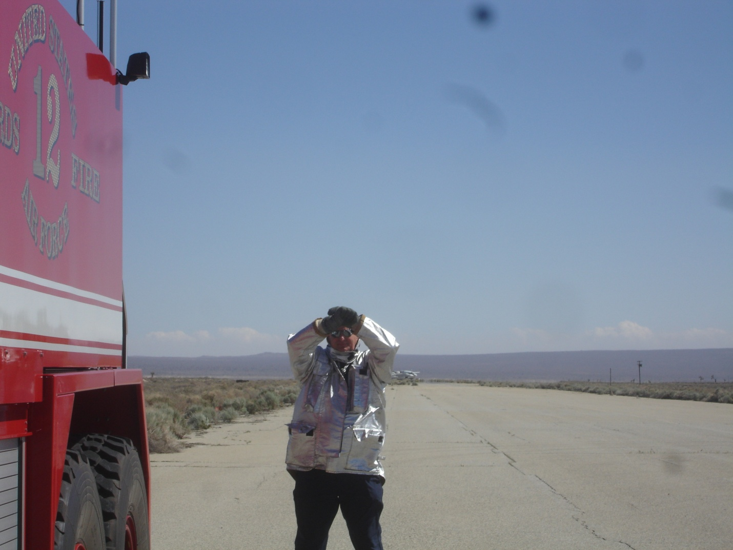
STOP: Facing the apparatus raise both arms with elbows bent clasp the hands together, palms facing, at the chin level. Hold that position until the signal is understood. Always be able to see the drivers mirror and stand on the driver’s side of the apparatus. If the backer sees the drivers mirror then the driver sees the backer, if the driver is looking in the mirror and paying attention

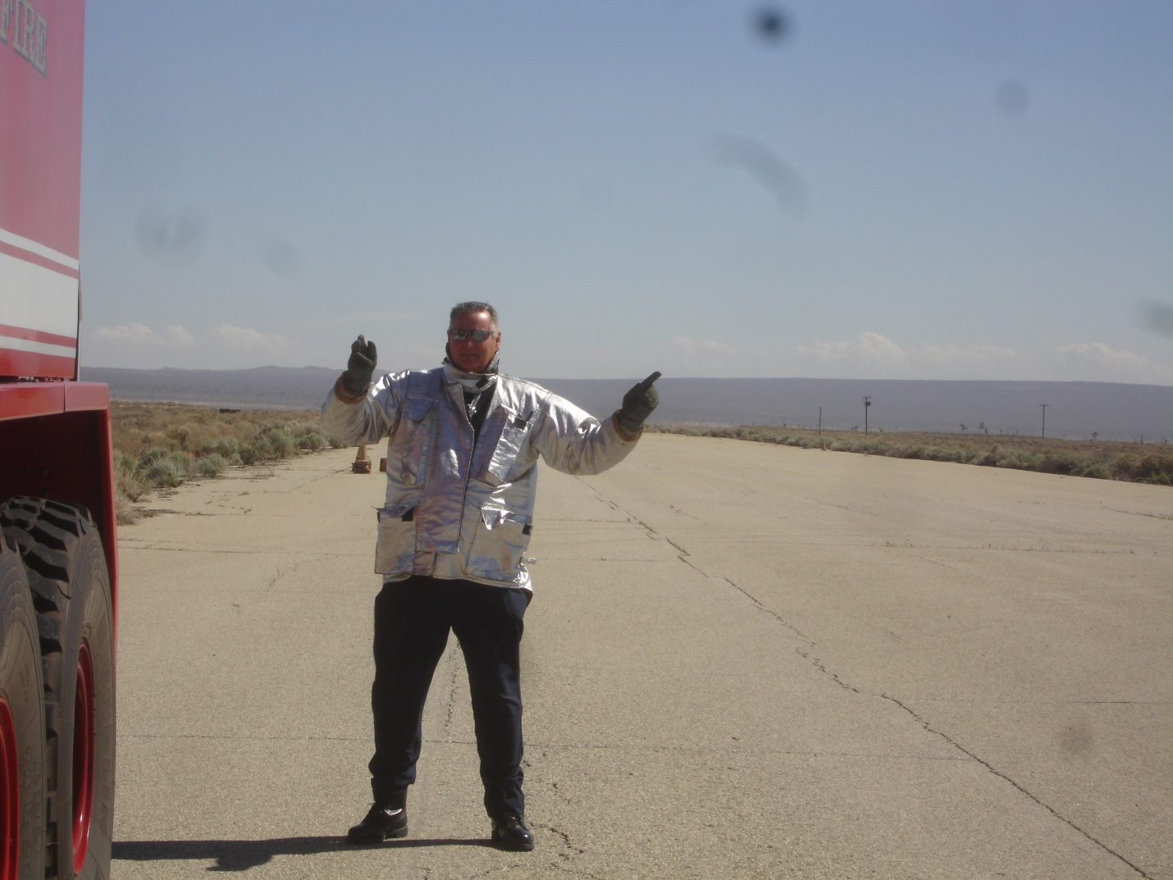
LEFT TURN: Extend the left arm horizontally to the side palm outward and use the right arm to motion the driver back.
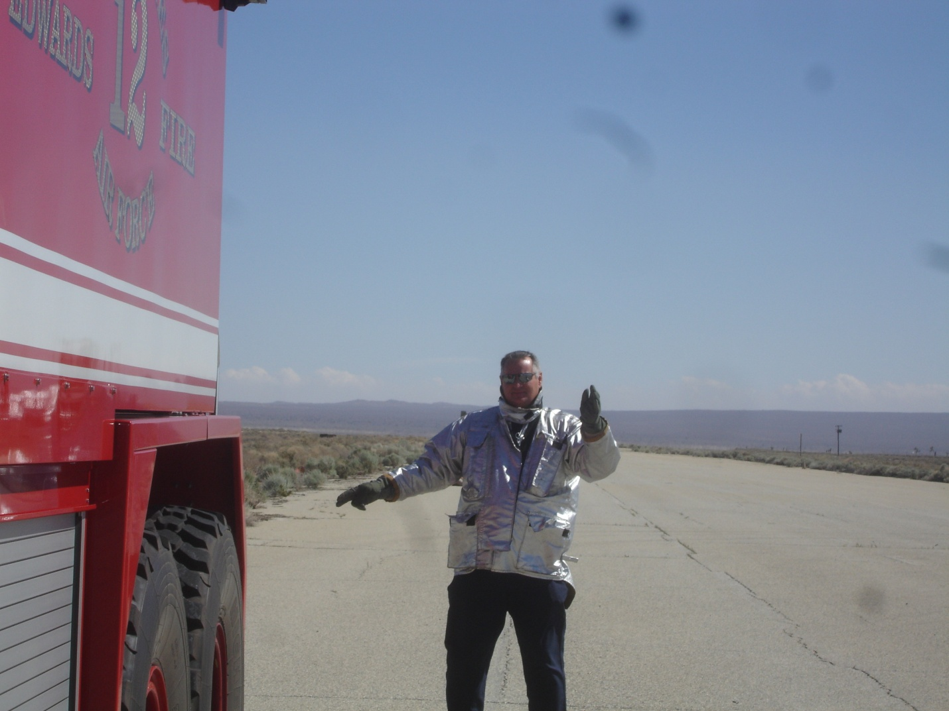

RIGHT TURN: Extend the right arm horizontally to the side palm outward and use the left arm to motion the driver back.

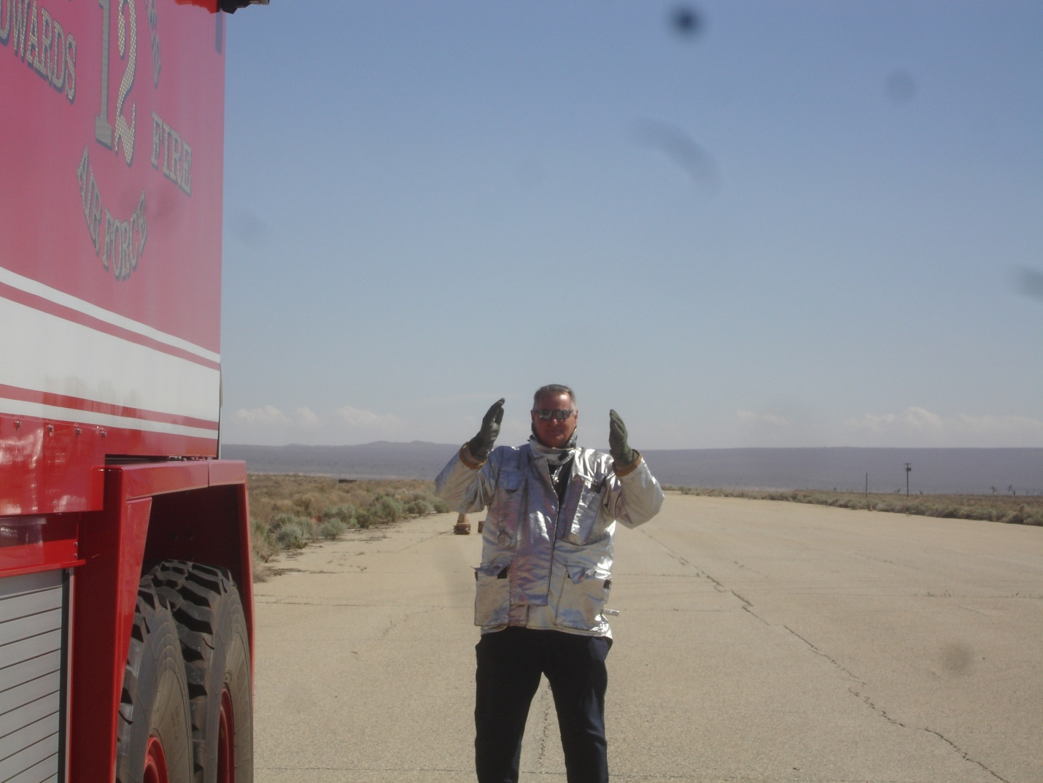
STRAIGHT BACK: Bending both elbows palms toward one another and parallel with the backer’s legs motioning front to back.

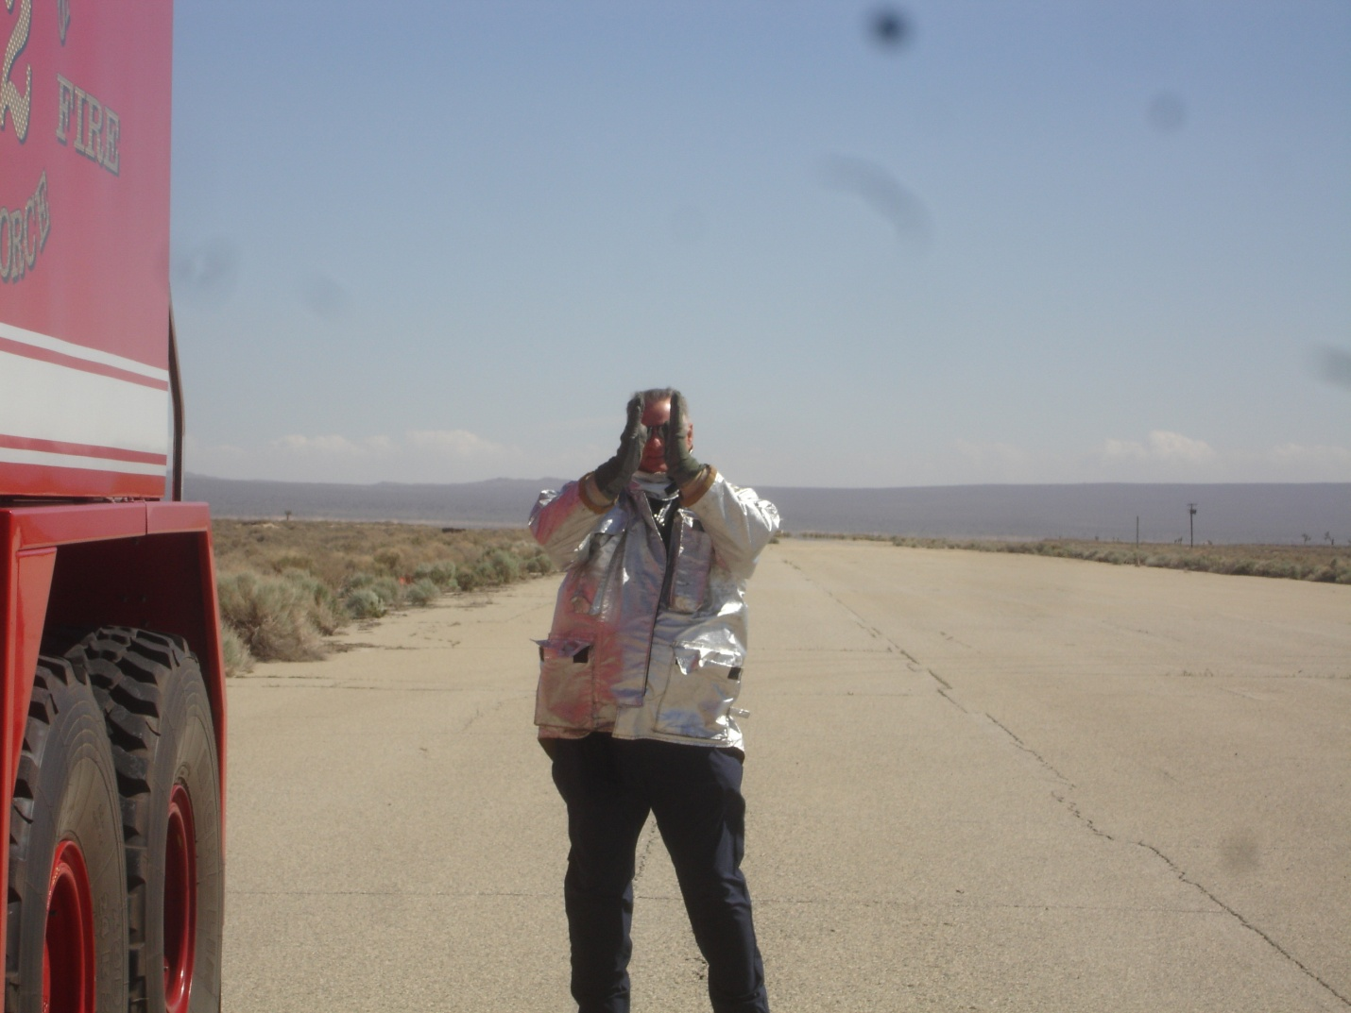

CLOSE THE DISTANCE BETWEEN THE APPARATUS AND OBSTRUCTIONS AND STOP: Face the vehicle being signaled, extend the forearms to the front, palms inward and separated the distance between the apparatus and the obstruction. Bring the palms together as the apparatus approaches the obstruction. The apparatus must stop when the palms come together.

